THIS IS A TEMPLATE/BASIC STARTING POINT. CUSTOMIZE THIS TEMPLATE WITH INFORMATION PERTINENT TO YOUR SETUP AND THE PROCEDURE YOU WILL BE USING/YOUR GROUP’S PERSONAL USE.

STANDARD OPERATING PROCEDURE

Procedure Title: |  | Sharps: Handling, Storage, and Disposal
Dept: |  |  |  | Bldg/Rm: |  |  | Supervisor:

Procedure Overview:

Sharps refer to any instrument that can puncture, cut, or scrape body parts. Examples include but are not limited to scalpels, awls, needles, X-Acto knives, utility knives, scissors, razor blades, Pasteur pipets, sharp or broken glass, lancets, glass capillary tubes, microtome blades, dental scalers, microscope slides and covers, serological pipettes, laboratory glassware, pipette tips, laboratory plastics such as petri dishes and culture flasks that shatter when broken, etc. The use of sharps is restricted to trained personnel and no alternative is available.

Health and safety information for materials used:

- Cuts, punctures, or scrapes may occur when retrieving, and/or handling sharps. Injuries may also occur when changing blades/needles, or if the sharp is dropped.
- Exposure to contamination from used sharps by cut, puncture, or scrapes.
- Exposure to contamination from the creation of aerosols.
Hazard Control Measures:
 | Latex gloves |  | Insulated gloves |  | Face shield |  | Respirator
 | Nitrile gloves |  | Safety glasses |  | Lab coat |  | Fume hood
 | Neoprene gloves |  | Vented goggles |  | Apron |  | Biosafety cabinet
 | Vinyl gloves |  | Splash goggles |  | Dust mask |  | Glove box
 | Fully enclosed shoes |  | Long pants |  | Flame resistant lab coat |  | Cut Resistant Gloves (Optional)

Other Control Methods:
Before Using Sharps
- All personnel who are likely to have occupational exposure to human blood, human or non-human primate-derived cell lines, or other potentially infectious materials that may carry bloodborne pathogens must complete the following:
  - Complete a Hazard Inventory Form.
  - Be offered a Hepatitis B vaccination and complete a Hepatitis B Consent or Decline of Vaccination Form.
  - Receive initial and annual Bloodborne Pathogens Exposure Control training.
  - Read and understand the Bloodborne Pathogens Manual.
- A sharps policy must be in place for safe handling of sharps if working in BSL1-3 labs.
- Eliminate the use of sharp devices whenever possible.
- Select the right tool for the task. See Safer Sharps Evaluation Form.
  - Make sure the blade is sufficiently sharp. Injuries can result from the cutting tool slipping if the blade is dull and the user compensates by applying excess pressure.
  - Use a sharp with an engineered safety feature when available. See available options here.
    - Example: If a needle syringe is necessary, use a syringe that automatically re-sheathes the needle.
    - Use disposable safety scalpels with fixed blades whenever possible. These devices eliminate the need to remove a blade.
  - Needles and syringes should never be used as a substitute for pipettes.
- Train on proper techniques before using sharps with hazardous materials.
- Use cut-resistant gloves if practicable and does not affect dexterity.
- Ensure the lighting is adequate and the workspace is uncluttered.
- If using disposable sharps, have a sharps container readily available within arm’s reach for disposing of sharps immediately after use.
  - An appropriate sharps container should be leak-proof on the sides and bottom, puncture-resistant, can be permanently sealed, and labeled correctly.
Handling Sharps
- Sharps should be kept away from the fingers as much as possible. Handle the tools with their safety handles. Never touch a blade with your bare hands.
- Do not become distracted while handling a sharp object.
- Never pass sharps to another person hand to hand.
- Sharps should never be bent, sheared, or recapped; needles should not be removed from syringes after use.
- If a contaminated needle must be recapped or removed from the syringe, a recapping device, or the one-hand scoop method must be used.
- Make sure the blade is securely inserted into the tool handle.
- Use physical restraining devices or anesthesia when using sharps on animals if your hands or other body parts are in danger of being punctured.
- If applicable, use sharps on the surface of your worktable. Keep your legs and feet under the table to protect your body if you drop a sharp.
- Be attentive when using sharps in the glovebox to avoid puncturing the gloves.
- Work that may create biohazardous aerosols must be performed in a certified biological safety cabinet.
- Observe Universal Precautions when working with sharps that may contain bloodborne pathogens (refer to the Bloodborne Pathogens Manual).
Storing Sharps
- Do not leave unprotected sharps on bench tops or loose in drawers. Place in protective secondary containment.
  - Store capped cutting tools neatly in a cup or in a drawer with all blades facing in the same direction.
  - Store awls and needles with tips inserted into cork, pieces of board, blocks of foam or a pin cushion. Keep all tips aligned in the same direction.
  - Store utility knives and box cutters with blades retracted into the handle.
- On equipment with blades or other sharp surfaces, use proper lockout/tagout techniques when servicing or performing maintenance.
Methods:
Changing Blades
- Surgical scalpel:
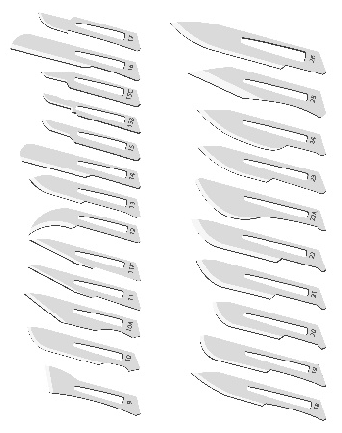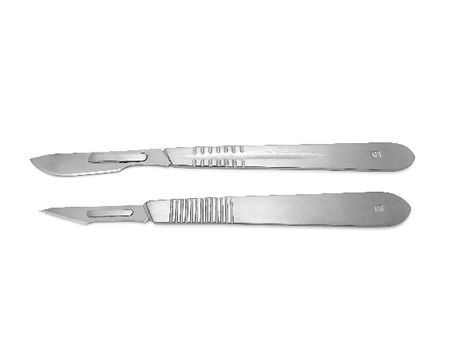
- Gather materials and work on a level and solid surface.
- Grasp the blade with tips of forceps or similar mechanical device near the end of the blade by the holder.
- Lift the blade slightly and slide it forward off the holder. Always pointing away from yourself and others.
- Dispose of the used blade in the appropriate sharps waste container.
- Obtain the scalpel holder that needs a blade added. Work on a level solid surface.
- Hold the blade within the packet with forceps or similar mechanical device.
- Open the scalpel packet by peeling the flaps apart with the forceps.
- Ensure the packet is open enough that the handle of the blade is visible.
- Align the scalpel holder with the blade. Ensuring that the blade and scalpel holder are in the correct orientation.
- Push the tip of the holder into the hole in the blade, then slide the holder forward to fit the blade into the groove.
- Point the tip of the scalpel blade down, touching it to the surface.
- Slide the slot on the handle into the slot on the blade by pressing down on the tip of the scalpel blade, driving it gently into the surface.
- If aligned and inserted properly, the blade will make a quiet clicking sound when securely attached.
- Remove the blade from the package.
- X-Acto Knife:
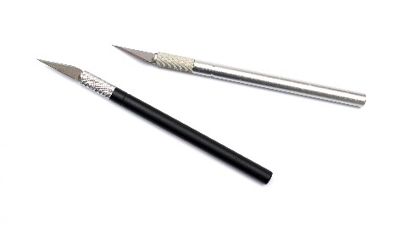
- Gather materials and work on a level and solid surface.
- Unscrew the bottom part of the handle that is next to the blade. This widens the slot around the blade.
- Slide the dull blade out of the slot using a mechanical device such as tweezers.
- Dispose of the used blade in an appropriate sharps waste container.
- Using a mechanical device, such as tweezers, pick up the new blade by its unsharpened edge and insert it into the slot in the handle.
- Tighten the bottom part of the handle to narrow the slot around the blade until it is secure.
- Utility Knife or Box Cutter:
Customize the procedure for the specific model of utility knife or box cutter used in your lab.
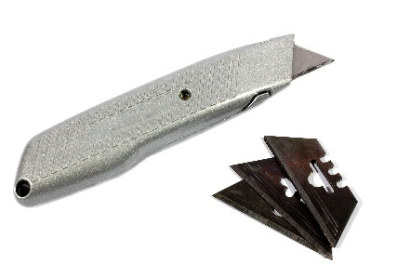
- Gather materials and work on a level and solid surface.
- Ensure the blade is retracted. Remove the retaining screw in the knife.
- Separate the top cover from the bottom one.
- Carefully remove the blade with a mechanical device such as needle nosed pliers.
- Dispose of the blade in an appropriate sharps waste container.
- Place the new blade in place using the needle nosed pliers.
- Replace the cover and tighten the screw to secure the blade.
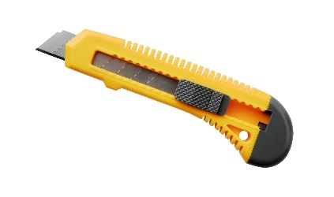
- Gather materials and work on a level and solid surface.
- Remove the base of the knife and the slide for the blade.
- Pull the cartridge out of the holder.
- Slide the catch on the backside of the holder, so the blade can be removed.
- Grasp the blade with a mechanical device such as needle nose pliers and pull it from the holder.
- Dispose of blade in an appropriate sharps waste container.
- Slide the new blade into the cartridge using needle nosed pliers.
- Align the hole of the blade with the hole in the cartridge.
- Slide the catch on the backside of the cartridge into place.
- Replace the cartridge back into the holder.
- Replace the slide and the base of the knife.
- Microtome Blades
Customize the procedure for the specific model of microtome in your lab.
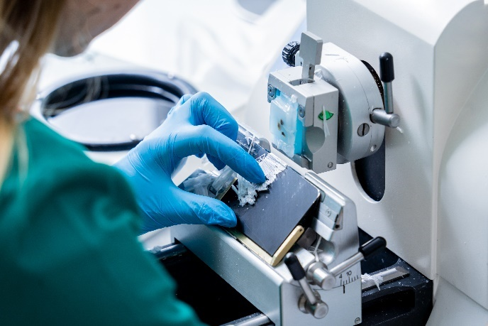
- Ensure the rotary handle of the microtome is in the locked position.
- Disposable blades must always be removed using forceps or a similar mechanical device.
  - Do not remove the blade holder from the microtome with the blade intact.
- Place blades in appropriate sharps waste container using a mechanical device such as forceps.
- Place a new blade in the blade holder using forceps and clamp it shut to secure the blade.
- Unlock the rotary wheel.

Recapping Needles
*Needles should not be recapped, bent, removed, or otherwise manipulated by hand! If it is essential that a needle be recapped due to the nature of the work, the use of a recapping device or the one-handed scoop method must be used.

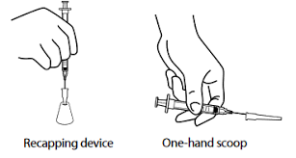

- Recapping Device
- Place the cap for the needle into the device.
- Slide the needle into the cap.
- Twist the cap to release from device.

- One Hand Technique
- Place cap on a solid surface.
- Holding the syringe with needle attached, slide the needle into the cap without using the other hand.
- Slowly tip the needle end of the device and allow the cap to slide over the needle.
- Push the capped needle against the solid surface to secure the cap with one hand only.
Waste Disposal Procedures:
For disposal of radioactive sharps reference Radioactive Materials Disposal SOP. Sharps waste must be placed in rigid, leakproof, puncture-resistant containers. Items that are also contaminated with biohazardous material must be decontaminated before EH&S collection.
Metal Sharps:
Do not overfill sharps containers! Overfilled sharps containers increase the risk of needlesticks or cuts.
- Non-infectious sharps: collect in leakproof, puncture-resistant container labeled as “Non-Infectious Syringes and Metal Sharps Only” label.
  - If the sharps are contaminated with heavy metals such as Mercury, Cadmium, or Selenium submit them in separate leakproof, puncture resistant containers and label as “XX” contaminated sharps.
- If the sharps are contaminated with Biohazardous Materials, the disposal method will depend on the biohazard:
  - Collect in autoclavable, leakproof, puncture-resistant container labeled with a Biohazard label.
    - After autoclaving and the container has cooled, cover Biohazard label with “Non-Infectious Syringes and Metal Sharps Only” label.
  - Collect in red biohazard sharps container. When full, close the bin permanently. Submit to EH&S for pickup.
- When the sharps waste containers are full and decontaminated (if applicable), contact EH&S for waste pick-up. Do not re-use sharps waste containers.
Glass Sharps:
- Collect in a leakproof, puncture resistant container labeled Broken Glass or a yellow tidy cat container available upon request from EH&S.
- If the glass is contaminated with Biohazardous materials:
  - Collect in an autoclavable, leakproof, puncture-resistant container labeled with a Biohazardous label.
  - After autoclaving, allow time for glass/container to cool. Do not re-use autoclaved containers. Once decontamination is complete, the glass can be disposed of as non-contaminated glass.
- Place in a yellow glass disposal bin on dock for disposal. If there is no bin, place bucket on dock and call FP&M (515) 294-5100 for pick-up.
- If the sharps are contaminated with heavy metals such as Mercury, Cadmium, or Selenium collect them in separate leakproof, puncture resistant containers and label as “XX” contaminated sharps and submit to EH&S for pickup. Do not dispose of into the yellow bin.
Plastic Sharps:
- Collect in a plastic-lined cardboard box labeled “Plastic Sharps”.
- If contaminated with Biohazardous materials:
  - Collect in autoclave bag with Biohazard label.
  - After autoclaving and the bag has cooled, place inside a plastic-lined cardboard box, seal, and label “Plastic Sharps”.
- Place sealed box in regular trash dumpster.
- If contaminated with heavy metals such as Mercury, Cadmium, or Selenium collect them in plastic-lined cardboard box, seal, and label as “XX” contaminated plastic sharps and submit to EH&S for pickup.
First Aid Procedures:
- If you sustain a minor cut or puncture to your fingers/hands, wash your fingers/hands with soap and cold water in the lab sink for 15 minutes. Once the bleeding stops, apply antibiotic ointment and a band-aid.
- If injuries are more significant, apply pressure and seek immediate medical attention and/or call 911. Always seek medical evaluation for exposure to materials that may contain bloodborne pathogens.
- If you are exposed to hazardous chemicals or biological materials via the laceration, follow your Safety Data Sheet for first aid procedures.
- The employee’s supervisor should be notified of any injuries as soon as possible. Follow procedures https://www.ehs.iastate.edu/services/occupational/accidents-injuries.
Decontamination, and Clean Up Procedures:

If you need to clean residue from a blade, do so on the surface of your worktable, not on the surface of your palm or fingers. Wipe the blade against a folded paper towel, a piece of cardboard or an antiseptic alcohol wipe.
If you are unable to clean the blade without touching the sharp edge, wear cut resistant gloves. However, it should be noted that wearing cut resistant gloves can add extra bulk to your fingertips and therefore make it more difficult to manipulate the small blades and handles. This can result in dropping the tool or the blade slipping during cleaning.
For a biological spill containing sharps see the Biological Spill Cleanup Procedures on the EH&S website.

For radiological spills containing sharps reference the Radiological Spills and Contaminations page on the EH&S website.
Written By: |  |  | Date:
Approved By: |  |  | Date:
(PI or Lab Supervisor)

HAZARD ASSESSMENT
Use the hierarchy of controls to document the hazards and the corresponding control measure(s) involved in each step of the procedure.

Consider elimination or substitution of hazards, if possible.
Engineering Control(s): items used to isolate the hazard from the user (i.e. fume hood, biosafety cabinet).
Administrative Control(s): policies/programs to limit the exposure to the hazard (i.e. authorizations, designated areas, time restrictions, training).
Required PPE: indicate PPE including specific material requirements if applicable (i.e. flame resistant lab coat, type of respirator or cartridge).

Task | Hazard | Engineering Control(s) | Administrative Control(s) | Required PPE
Sharps | Cuts, punctures, or scrapes | Use a sharp with an engineered safety feature. | Complete and document safety training. | Safety glasses, cut-resistant gloves(optional), long pants, fully enclosed shoes
Working with biohazardous materials | Cuts, punctures, or scrapes to the skin with a biologically contaminated needle or sharp.  Creation of aerosols.  Customize for specific agent. | Biosafety cabinet | Complete and document safety training. Learn the SOP. Enrolled in the Bloodborne Pathogens Program through EH&S. | Nitrile gloves, safety glasses, fully enclosed shoes, lab coat, long pants
Working with Radiological Materials | Cuts, punctures, or scrapes to the skin with a radiologically contaminated needle or sharp.  Customize for specific material. | Shield | Complete and document safety training. Enrolled in RAM program through EH&S. | Safety glasses, lab coat, nitrile gloves, long pants, fully enclosed shoes
Working with Hazardous Chemicals | See SDS for specific chemical hazards | Fume hood – if applicable | Complete and document safety training. Read the SDS. | Safety glasses, lab coat, nitrile gloves, long pants, fully enclosed shoes
Recapping Needle | The needle may miss the plastic cap or pierce the end of the cap, leading to a finger or hand puncture.  The cap could fall off leading to finger or hand puncture.  Puncture resulting from removing the needle from the syringe.  Exposure to biological, chemical or radiological materials. Customize for specific material. | Recapping device | Complete and document safety training. Written justification and instructions for an SOP that involves recapping. | Safety glasses, double gloves, lab coat, long pants, fully enclosed shoes

TRAINING RECORD
Use the following table to record the training associated with this Standard Operating Procedure.

Print Name | Signature | Trained By | Date

Sharps appendix
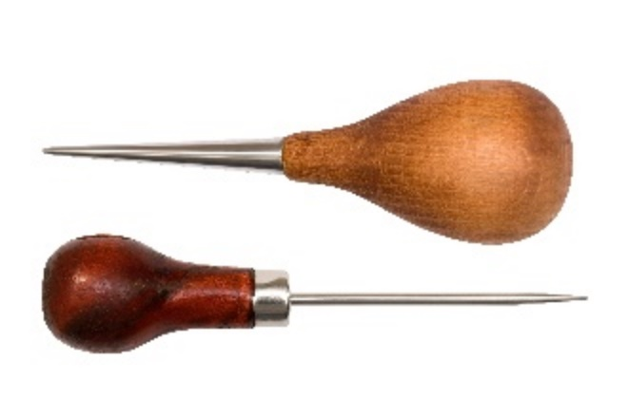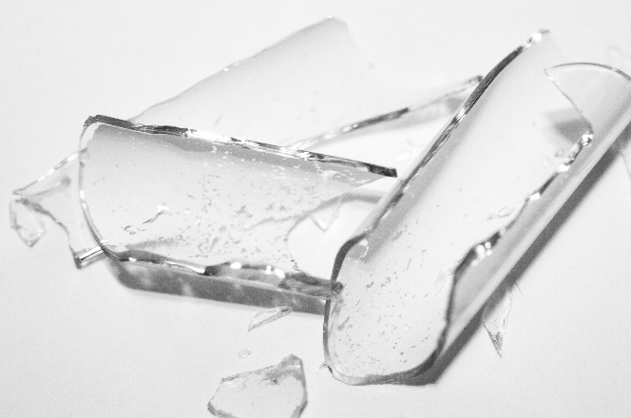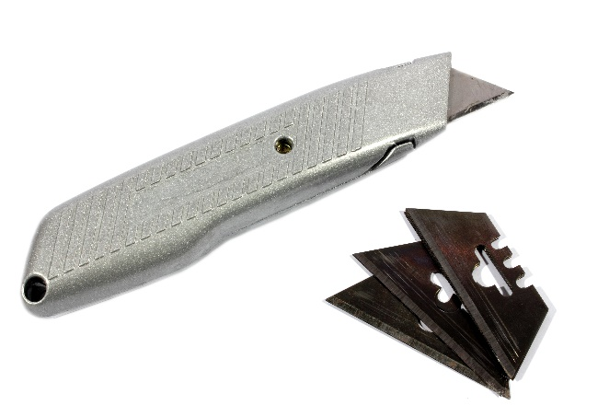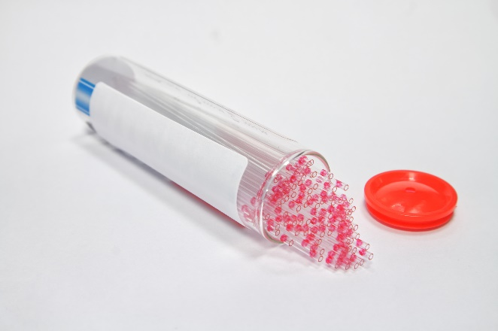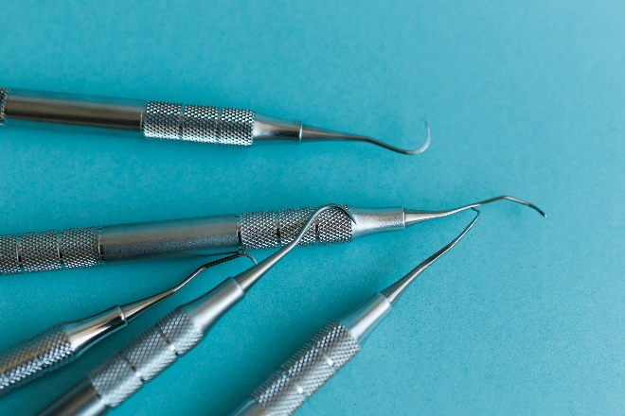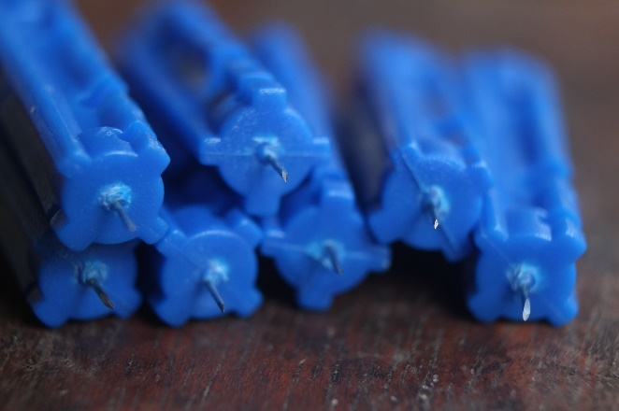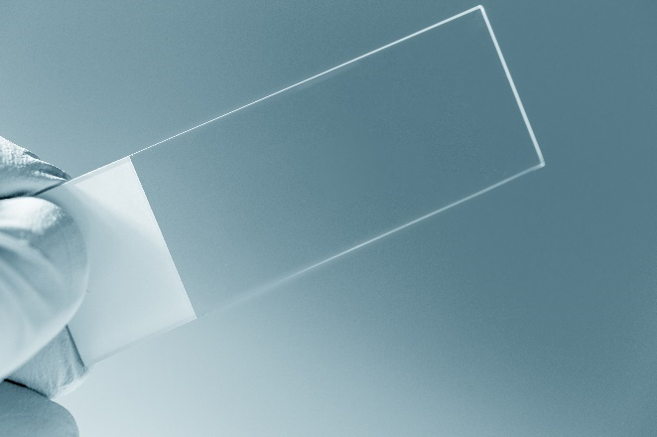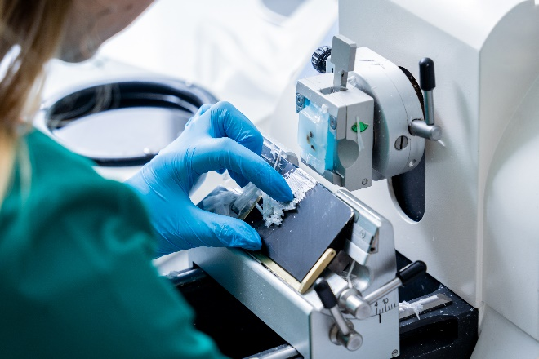
Microtome
Box Cutter
Capillary Tubes
Lancets
Dental Scalers
Microscope Slide
Broken Glass
Awl
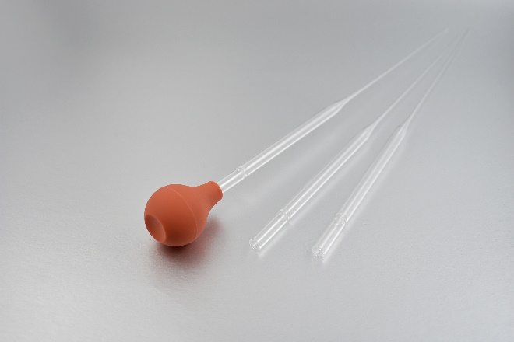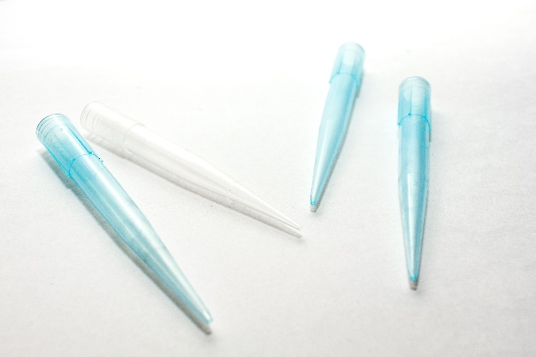
Pipette Tips
Pasteur Pipet
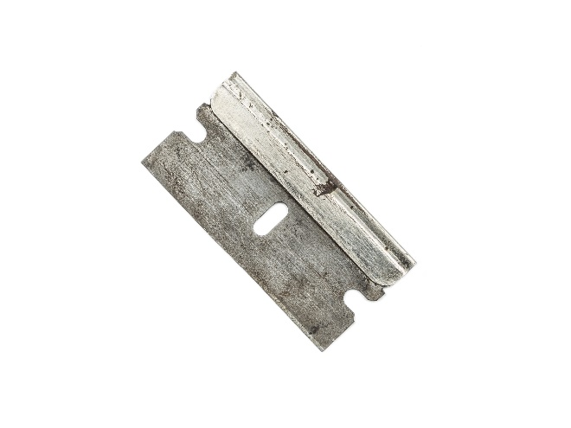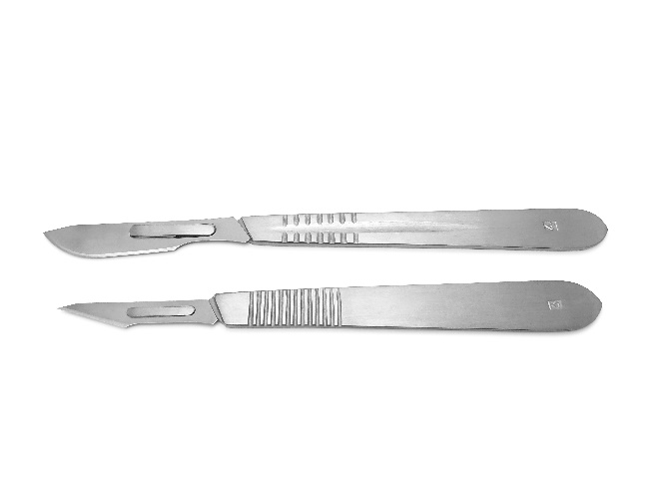
Scalpel
Razor Blade
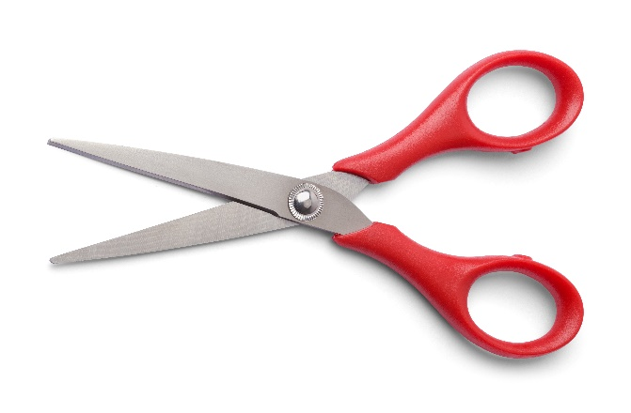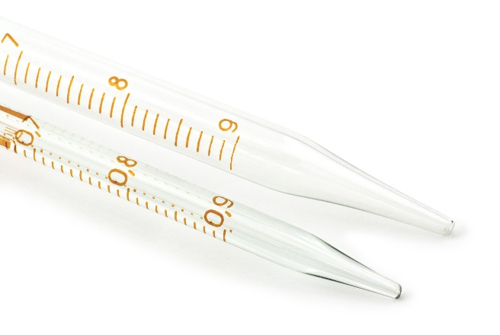
Serological Pipettes
Scissors
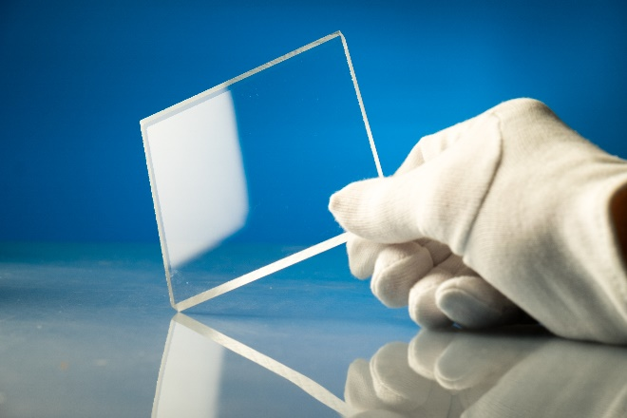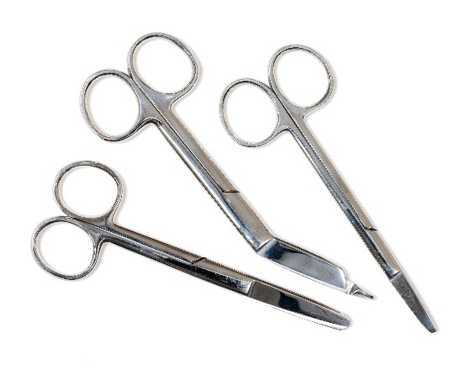
Surgical Scissors
Sharp Glass
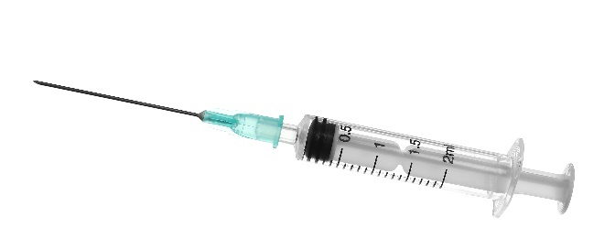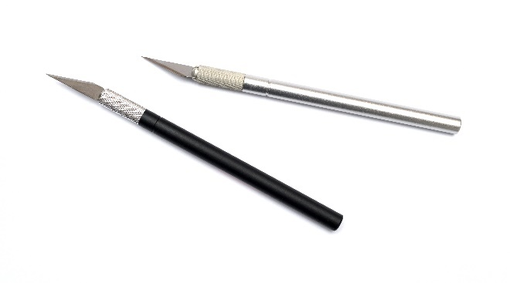
X-Acto Knife
Syringe and Needle

