Procedure Title: |  | Schlenk line (Vacuum/Gas manifold)
Dept: |  |  |  | Bldg/Rm: |  |  | Supervisor:

THIS IS A TEMPLATE/BASIC STARTING POINT. CUSTOMIZE THIS TEMPLATE WITH INFORMATION PERTINENT TO YOUR SCHLENK LINE SETUP AND THE REACTION YOU WILL BE RUNNING/YOUR GROUP’S PERSONAL USE.

Procedure Overview:

A Schlenk line is a piece of equipment/glassware used for removing oxygen and water from reaction vessels via purge/refill or freeze-pump-thaw and/or performing reactions under inert atmosphere.

Health and safety information for materials used:

The Schlenk line must be located inside a fume hood. Hazards can include implosion from low pressure, explosion from overpressure, lacerations from broken glass, explosion from condensing oxygen in the cold trap, fire and burns from pyrophoric chemicals, cold burns and asphyxiation from liquid nitrogen, and exposure to hazardous chemicals.

Use of compressed gas cylinders is hazardous and includes asphyxiation from rapidly expanding gases displacing oxygen, physical hazards from falling cylinders, and/or explosion from cylinder rupture.

Many materials used within the line are reactive to air or water. Read the SDS and understand the hazards of all materials before beginning work. INSERT SPECIFIC CHEMICAL SAFETY INFO HERE

IF YOU SEE CONDENSED OXYGEN IN THE COLD TRAP – pale blue liquid – lower the dewar until the trap is just out of liquid nitrogen. Turn off the vacuum pump, turn off the inert gas flow, and open the line to the air. Close the sash and allow the oxygen to slowly evaporate as the liquid nitrogen evaporates. Evacuate the room and call EH&S. After the trap has come to room temperature, dangerous peroxides may have formed. Rinse the trap with water and test the solution with peroxide dip strips. Dispose of the rinse through EH&S.

Hazard Control Measures:
(Lab coat, eye and hand protection, and closed toe/heel shoes must be selected as required by Section D of the ISU Laboratory Safety Manual.)
 | Latex gloves |  | Insulated gloves |  | Face Shield |  | Respirator
 | Nitrile gloves |  | Safety glasses |  | Lab Coat |  | Fume hood
 | Neoprene gloves |  | Vented goggles |  | Apron |  | Biosafety cabinet
 | Vinyl gloves |  | Splash goggles |  | Dust mask |  | Glove box
 | Closed Toe/Closed Heel Shoes |  |  |  | Flame Resistant Lab coat

Procedure:

The Schlenk line consists of a vacuum manifold connected to a vacuum pump, and an inert gas manifold connected to a source of purified and dry inert gas (typically argon or nitrogen). The inert gas vents through a bubbler (oil or mercury), which allows the pressure to be monitored. A liquid nitrogen cold trap is used to condense solvent vapors. The two manifolds are connected by double oblique glass stopcocks or teflon taps.
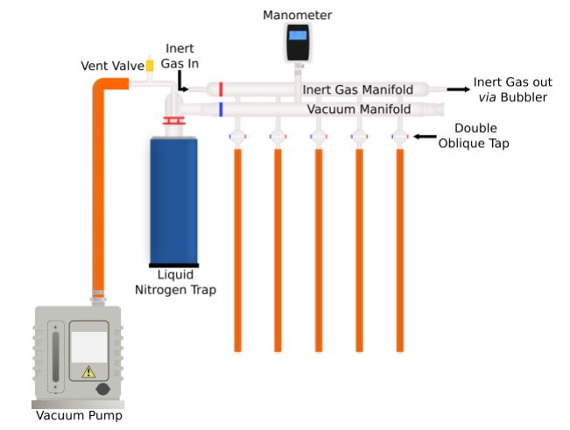
Figure 1. Schlenk line diagram https://schlenklinesurvivalguide.com/
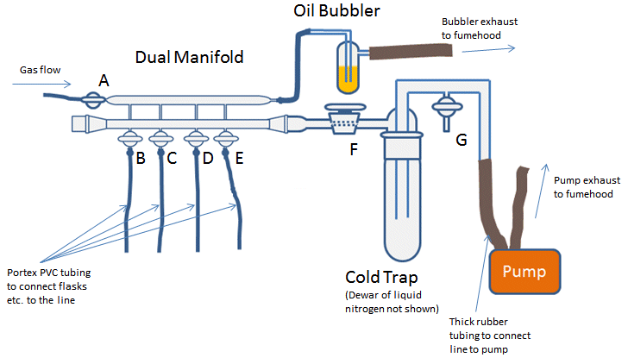
Figure 2. Schlenk line diagram https://www.chemistryviews.org/details/education/3728881/Tips_and_Tricks_for_the_Lab_Air-Sensitive_Techniques_1.html

Before using the Schlenk Line:
- Ensure that the vacuum pump has sufficient oil (changed at appropriate intervals) and is properly connected and ventilated/exhausted. An oil mist filter is not a substitute for proper exhausting/ventilation of the pump.
- Check connections/seals and glassware (for cracks or weaknesses).
- Ensure that the line is cold trapped.
- Ensure that the compressed gas cylinder has sufficient supply.
- Ensure that the bubbler is connected and vents inside the fume hood.
Using the Schlenk Line:
- Ensure all taps on the line are closed.
- Connect your reaction vessel to the desired tap. Use a clip to secure the connection.
- Ensure that all joints have a good seal – use vacuum grease, clips, rubber septa, stopcocks, etc.
- Do not open the flask to inert gas and vacuum at the same time.
- Do not pull vacuum while the system is open to air.
Using the Vacuum Line:
- Ensure the line is cold trapped: fill the dewar and immerse the trap if you have not already done so. Check the dewar periodically and add more refrigerant (typically liquid nitrogen) to ensure the level never falls below 50% full.
- Ensure that all taps and valves on the Schlenk line are closed.
- Turn on the vacuum pump.
- Ensure that the valve between the inert gas cylinder and the line is closed (See A in Figure 2).
- Slowly open the valve between the cold trap and the line (See F in Figure 2).
- Slowly open the tap connected to your reaction vessel.
- When you are finished, close the tap to your reaction vessel.
- Close the valve between the cold trap and the line (See F in Figure 2).
- Turn off the vacuum pump and remove the dewar from the cold trap. DO NOT LEAVE A COLD TRAP WITHOUT A VACUUM RUNNING. DO NOT OPEN THE SYSTEM TO AIR WHILE A COLD TRAP IS ATTACHED TO THE LINE. THIS CAN CONDENSE OXYGEN, WHICH IS EXPLOSIVE.
- Open at least one tap to remove the vacuum pressure from the line, then close it again.
- Empty and clean the trap, dispose of remaining liquid nitrogen from the dewar. Replace the trap for next use.
Using the Inert Gas Line:
- Ensure that all taps and valves on the Schlenk line are closed.
- Open the valve on the compressed gas cylinder.
- Slowly open the valve between the inert gas cylinder and the line (See A in Figure 2).
- You should see bubbles start in the gas bubbler. Adjust the flow until it reaches the desired rate.
- Slowly open the tap to your reaction vessel. Double check the bubbler and adjust the flow rate if needed.
- When you are finished, close the tap to your reaction vessel.
- Close the valve between the cylinder and the line (See A in Figure 2).
- Close the valve on the compressed gas cylinder.
- Turn off the vacuum pump and remove the dewar from the cold trap. DO NOT LEAVE A COLD TRAP WITHOUT A VACUUM RUNNING. DO NOT OPEN THE SYSTEM TO AIR WHILE A COLD TRAP IS ATTACHED TO THE LINE. THIS CAN CONDENSE OXYGEN, WHICH IS EXPLOSIVE.
- Empty and clean the trap, dispose of remaining liquid nitrogen. Replace the trap for next use.

Waste Disposal Procedures:
Any waste from the vacuum trap should be emptied after the experiment is completed and disposed of appropriately (insert specific disposal instructions here). Dispose of Schlenk lines as glassware waste, if necessary.

First Aid Procedures:

Glass explosion: If there are no chemical exposures and the lacerations are manageable, perform first aid – clean and bandage the wound(s). If the lacerations are not manageable, apply pressure and seek medical attention. If there are chemical exposures, consult the Safety Data Sheet and perform first aid and/or seek medical attention. INSERT SPECIFIC FIRST AID FOR EXPOSURES HERE

Collect the broken glass using a brush and pan and dispose of as a glass waste if it is clean or as chemical waste if it’s contaminated.

All accidents and injuries occurring at work or in the course of employment must be reported to the employee's supervisor as soon as possible (even if no medical attention is required).
http://www.ehs.iastate.edu/occupational/accidents-injuries

Spill/Release Containment, Decontamination, and Clean Up Procedures:

Use the laboratory spill kit to control the spill. Consult the Safety Data Sheet for specific instructions.

Written By: |  |  | Date:
Approved By: |  |  | Date:
(PI or Lab Supervisor)

- HAZARD ASSESSMENT
Use the hierarchy of controls to document the hazards and the
corresponding control measure(s) involved in each step of the procedure.

Consider elimination or substitution of hazards, if possible.
Engineering Control(s): items used to isolate the hazard from the user (i.e. fume hood, biosafety cabinet).
Administrative Control(s): policies/programs to limit the exposure to the hazard (i.e. authorizations, designated areas, time restrictions, training).
Required PPE: indicate PPE including specific material requirements if applicable (i.e. flame resistant lab coat, type of respirator or cartridge).

Hazard | Engineering Control(s) | Administrative Control(s) | Required PPE
Glassware under pressure – explosion or implosion can cause lacerations | Fume hood | Complete and document training. | Lab coat, appropriate gloves, safety glasses, closed shoes
Chemical Exposure – Schlenk lines are used with a wide variety of hazardous chemicals. Consult Safety Data Sheet for specific hazards of each material. | Fume hood, proper storage, proper disposal | Complete and document training | Lab coat, appropriate gloves, safety glasses or splash goggles, closed shoes.
Cryogenic liquids – cold burns, blisters, frostbite | Use the dewar pouring system if you have one. | Training – place the dewar on the floor to fill it. | Thermal gloves, face shield, safety glasses, lab coat, long pants, closed shoes.
Liquid Oxygen can condense in the cold trap if air is pulled through the vacuum or system is opened to air while still cold-trapped | Fume Hood, sash closed | Complete and document training on how to properly use a Schlenk line and what to do if oxygen is condensed in the trap. | Lab coat, appropriate gloves, safety glasses, closed shoes
Pyrophoric materials are often used with Schlenk lines – they react violently with air and water – burns, explosions, chemical exposure. | Fume hood | Complete and document training. | Flame resistant lab coat, appropriate gloves, safety glasses/goggles, closed shoes
INSERT SPECIFIC HAZARDS/CONTROLS HERE

- Training Record
Use the following table to record the training associated with this Standard Operating Procedure.

Print Name | Signature | Date

